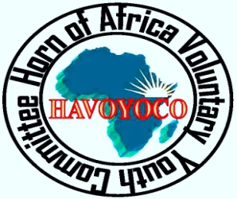

Report on Voter ID Cards distribution awareness campaign in Sanaag Region.

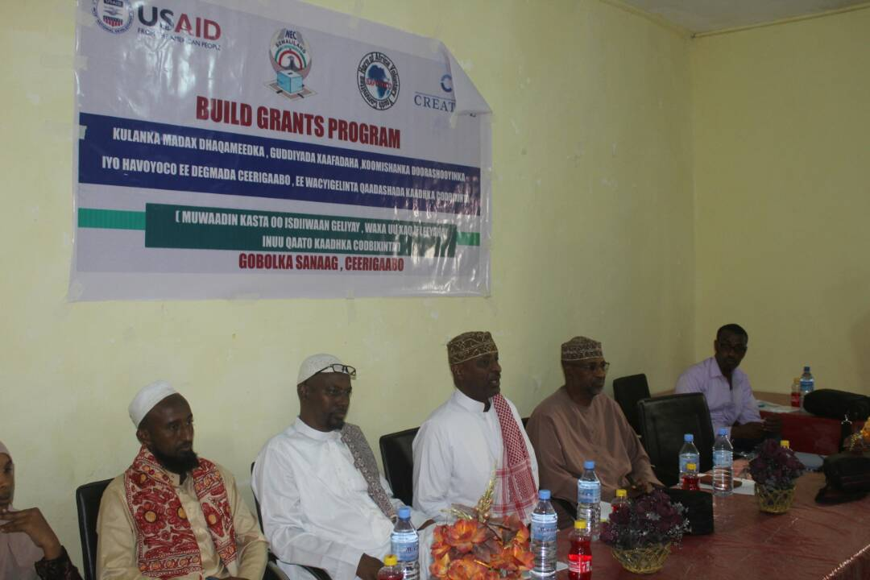

Photo File:some of the portraits from the voter education events

Kamal Hassan

And Hassan Hayir
HAVOYOCO
August, 2017

OVER VIEW OF THE PROJECT

Through this grant, the United States Agency for International Development (USAID)-funded Bringing Unity, Integrity, and Legitimacy to Democracy (BUILD) project will support the Horn of Africa Voluntary Youth Committee Organization(HAVOYOCO) to implement a voter awareness campaign in Somaliland’s Tog-dheer and Sanaag Regions. The campaign, which will be implemented in close collaboration with the National Election Commission (NEC), will raise awareness among registered voters/communities about NEC’s voter identification (ID) distribution process for the upcoming Somaliland presidential election on November 13, 2017

in Somaliland, five elections were held peacefully and considered free and fair elections as the domestic and international observers accounted. Despite this, upholding Somaliland elections are vital in democratization, development, state building and peace building, achieving accountable and transparent government and the path to recognition. However there have been equivalent challenges that were not addressed and overshadowed all of the elections

ACHIEVEMENTS

- Central –Level community Meeting.

On 4th August, 2017 HAVOYCO together with NEC conducted Central level community meeting on Voter ID Card distribution awareness prior to voter ID collection which is planed 12th August in Sanaag Region. This meeting was invited and attended 101(72 Male and 29 Female) participants from community leaders, traditional elders, youth group, women groups, District Committees and Representatives of commissionaires include Mr.Saed Ali Mouse Mr. Abdurahman Osman Adem Mr. Mohamed Jama And Amina Hamoud.
The meeting was officially opened by Mr; Hassan Ahmed Hayir from HAVOYOCO, he welcomed everyone to the meeting, and at the same time, he deeply explained the process that HAVOYOCO planed for the conducting awareness campaign on voter cards ID distribution throughout the Sanag region. Also, Amina Hamud from NEC task force informed to the participants about the process of the mobilization related to the voter ID distribution campaign in Sanaag Region, and the cooperation between the National Electoral Commission and HAVOYOCO.
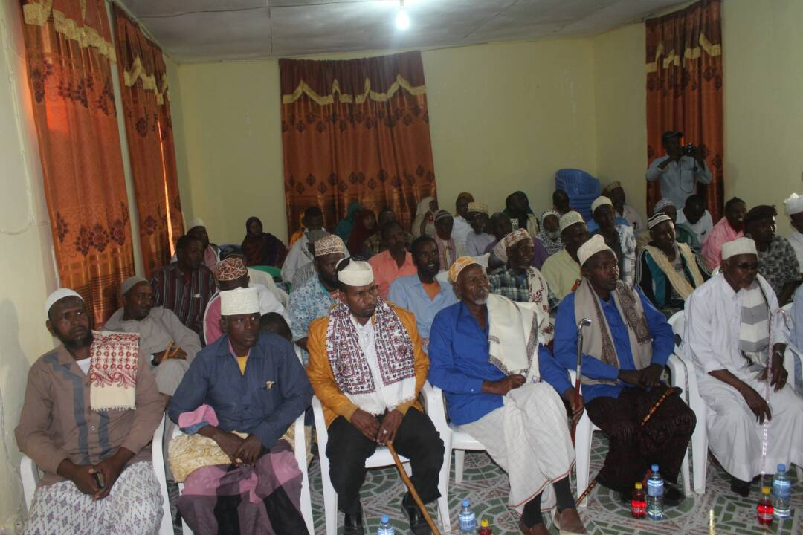
All the three members from NEC presented the importance of the voter ID distribution, which is expected to begin in the Sanaag Region mid of August, they strongly advised to the participants to fully participate the awareness campaign on Voter ID Cards. At end of the meeting the commissionaires encouraged the participants to actively participate in public awareness and mobilization campaigns before and during voter ID card distribution. All different groups have raised questions and shared their view opinions and thoughts about the voter ID distribution. During the meeting some members of the participants have shared their opion and thoughts about the best ways on voter ID card distribution awareness
Participants recommended
- they also promised to continue mobilizing until the end of the distribution period
- the elders and traditional leaders also promised that they will work HAVOYOCO and NEC as voluntary basis
- Respecting the Rules and regulations of NEC
- Observing and keeping Security of the sites

- Community Mobilizers Training in Erigavo district .

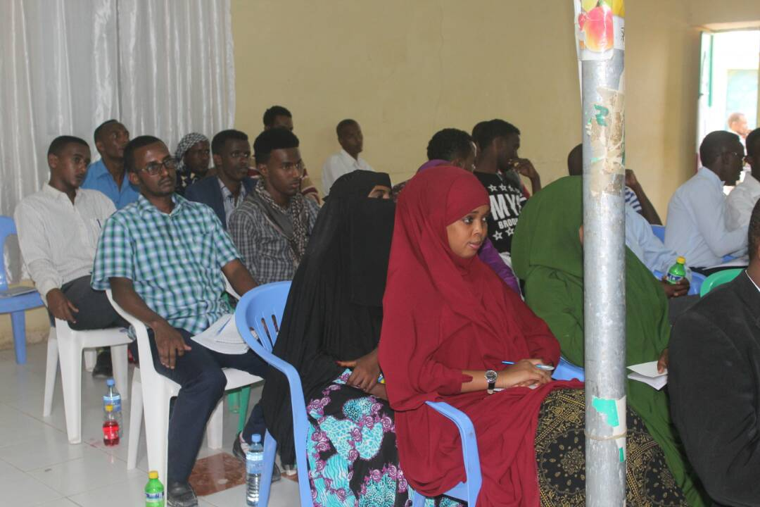
On 5th -6th August. HAVOYCO and National electoral commission have trained a total of 14 (12 male and 2 Female ) of community mobilizer, the objectives of the this training was to increase the knowledge of targeted communities through Mounted vehicles with public awareness in order to increase people’s understanding of importance of voter ID ,distribution so as to participate and disseminate the key messages of voter ID distribution. The participants have limited knowledge about community awareness campaign but equipped all necessary information and had given and practical examples by using role play and finally they understood well and the participants have acquired skills on community mobilization methods

Key topics covered

- Duties and responsibilities of community mobilizers
- Site and locations that people can get their voter ID
- Time frame voter ID distribution. Awareness campaign
- Timeframe of voter IDP distribution
- voter ID distribution requirements
- identification to establish eligibility, the date, time, and place of voter ID in the voters’ districts
- necessary identification to establish eligibility, the date, time, and places of voter ID distribution in the voters’ districts,
- the consequences of attempting multiple collection of Voter ID;
- problem solving skills
- how to deliver the message through mounted vehicles .
- Basic education related to the issues of voter cards.
- Process and Benefits of Community Mobilization.
- At the end of the training, all participants come to understand what they should do and what they should not do during the mobilization period.
- All training participants gained advantageous skills namely:
- Good facilitation skills to enable or help communities to understand the process of the distribution of voter cards.
- Good communication skills to disseminate the right messages to the communities.
- Manual book for the education of voter ID cards provided to all mobilizers.

The workshop process consisted of presentations, guided discussions, working group sessions, discussions on shared experiences and the way forward.

- Distribution of IEC materials

HAVOYOCO in collaboration with NEC have distributed(50 T-shirts, , 4 banners ,100 cups , 200 A3 stickers, 180 A1stickers IEC material to the project targeted communities , the key messages were encouraging the people of Sanaag region to collect their voter ID cards during the distribution period.

- SUCCESS STORIES

Box 1: Success stories

Dacar a is 28 year old men, live in Erigavo , he is a disable person during the selection of the community mobilizers , the people in Erigavo recognized the that he is public speaker, therefore HAVOYOCO team added as community mobilize,Mr. Dacar became the best speaker and most influential person when it comes to dissemination of the key messages.

Challenges

High expectation of the community towards recruiting staff and getting incentives each and every activities

RECOMENDATIONS
- To educate the community more election process and voter education.
- To Provide particular support to promote the participation of women and marginalized groups
- If possible, in the future, it is important to extend the period of the awareness campaign.
- Community meetings are very essential for sensitizing the community gate keepers and giving the right information.

.

Annex 1: SOME PORTRAITS FROM THE PROJECT

