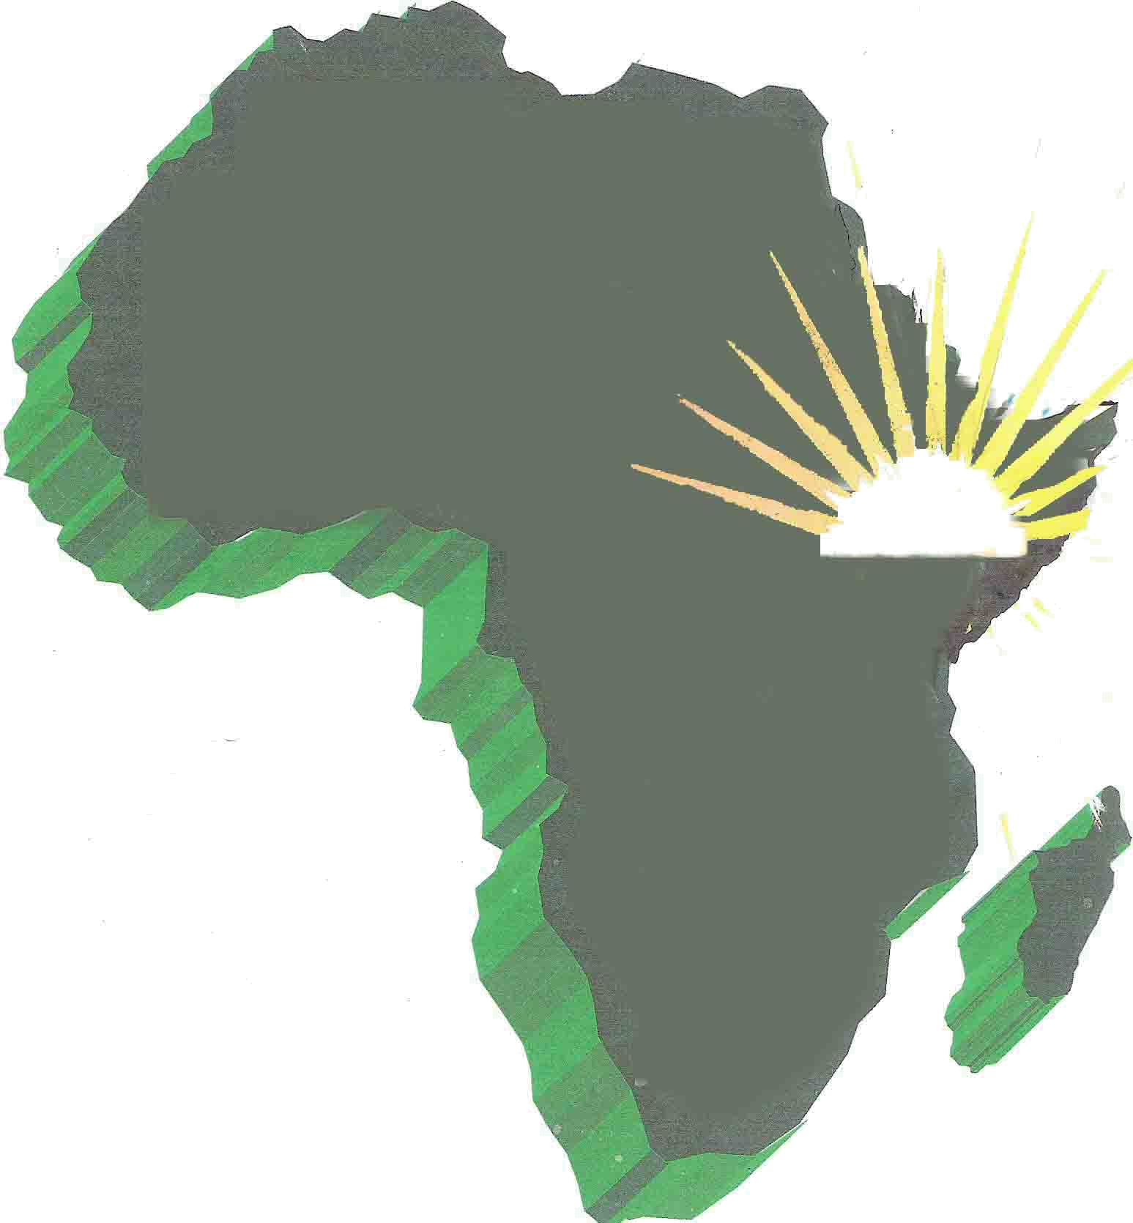
Horn of Africa Voluntary Youth Committee
HAVOYOCO

FINAL PROJECT REPORT
PROVISION OF COMPREHENSIVE DIARHEA PREVENTION/TREATMENT & MICRONUTRIENT CARE UNDER 5 AGE CHILDREN

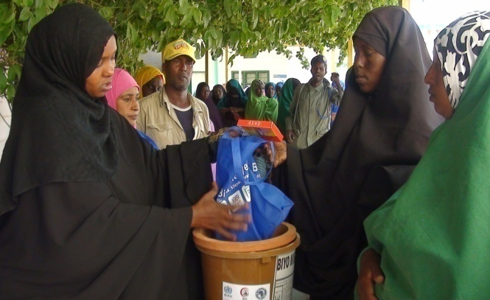
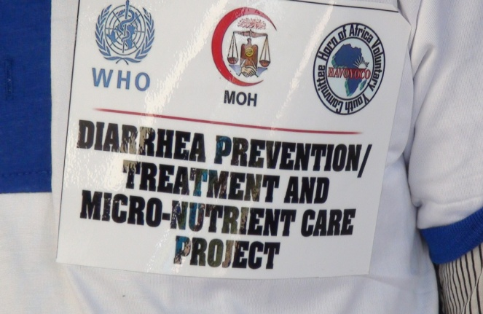

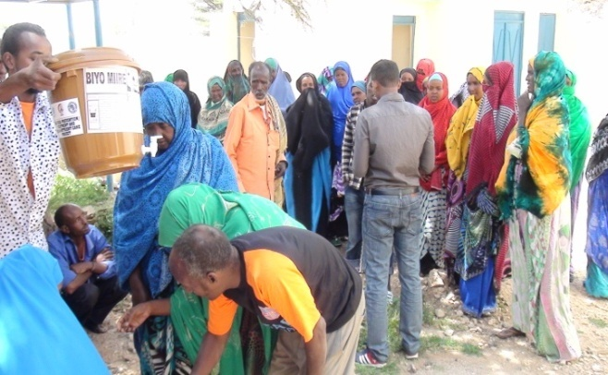
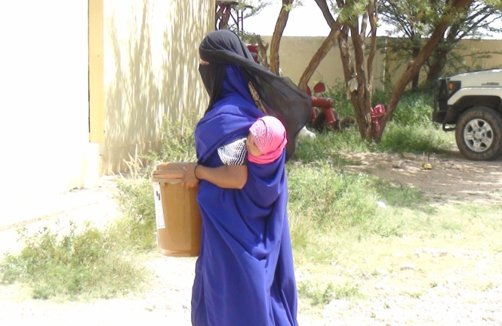

Photo File:some portraits of the project events and activities

Funded by: WHO Somalia Program

Duration: 1st June to 30th Nov 2016

Table of Contents
1. Executive Summary 3
2. Back-ground 3
3. Project goal,outcomes and outputs 4
4. The Project achievements 4
5. Procurement and distribution of health products. 5
6. Training for 60 health profesionals and non profesionals 5
7. Production & Distribution of IEC Materials 6
8. BCC on daiarhea prevention/treatment & IYCF 7
9. Challenges,Lessons learnt & Recomendations 8
10. Lessons learnt 8
11. Recomendations 9

10. Annexes 10
10.1. Photo of the project 11
10.2. List of government officers engaged 11

1.Executive Summary

This is the final progressive report from June, 2016 to November 2016. The report focuses on the implementation of the project named Provision of Comprehensive Diarrhea prevention/treatment & Micronutrient care for children under 5 age in Kallabaydh and Dilla town of Gabiley and Awdal regions in Somaliland. The report captures the implementation progress, achievements, challenges and recommendations.

This final report of the project shows that all activities scheduled for the project have been accordingly implemented
A total of 400 ceramic filters were distributed in two targeted villages (Dilla & kalabaydh) of Gabiley and Awdal regions in Somaliland, distributed16,000 of diarrhea treatment kits with ORS & zink as well 120,000 of aqua tabs were also successfully distributed in the target areas of the project
60 health professionals and non health professionals were trained on optimal use of IYCF,daiarhea prevention and treatment as well sanitation & hygiene promotion, on the other hand 500 posters & BCC activities with different key messages on child health (i.e. diarrhea prevention, treatment, hygiene promotion, IYCF and exclusive breastfeeding). furthermore Monitoring and supervision activities were carried out for project activities.
2.Background

Horn of Africa Voluntary Youth Committee (HAVOYOCO) is a regional Non -governmental Organization (NGO) operating in Somaliland and Ethiopia. HAVAYOCO was founded in 1992 and since its inception it has successfully implemented different development projects in Somaliland and Ethiopia. HAVAYOCO was initially set up with the aim of being a volunteer and learning institution and to address the needs of poor communities and marginalized groups in Somaliland.
The organisation has defined its strategic focus by clarifying its mandate and making thorough analysis of its external and internal environments. To maximise impact of its work the organisation will, over the coming five years, focus on delivering on five organisational priorities namely empowering and creating employment opportunities for youth, supporting pastoral and agro-pastoral communities, good governance ,improving mother and child health and nutrition and institutional capacity building and sustainability.

Somaliland has high child and infants mortality rate at 113 and 88 percent 1000 live birth respective .Diarrhea disease is one of the leading Cause of morbidity and mortality among children under five in Somaliland and 22.9% and 17.7% caregivers ( IDP and urban responsive report that their youngest child experience diarrhea .
The majority of diarrheal disease among children is transmitted through unsafe drinking water poor hygiene practice.

Malnutrition was major Cause of morbidity and mortality in worldwide and in particular in Somaliland .The notional micronutrient and anthropometric nutrition survey 2009 have also highlighted an alarming situation regarding micronutrient deficiencies in Somaliland.

HAVOYOCO signed a six months Agreement with WHO from June to Nov 2016 to implement Diarrhea prevention/Treatment and micronutrient care of under 5 children in Kalabaydh and Dilla villages

HAVOYOCO in collaboration with WHO, Ministry of health and village development committees implemented the project activities.

The CERF funds enabled HAVOYOCO to carry out this interventions that supported common humanitarian services that are necessary to enable life-saving activities.

3.The project goal, outcomes and outputs

The overall goal of the project is to contribute to the reduction in child morbidity and mortality due to diarrheal diseases in Somaliland and micronutrient deficiencies in Somaliland among children under five.

Project intended outcomes

Improved management of diarrhoeal disease and contribute to the reduction of micronutrient deficiencies among children under five

Project outputs:

- Increased access to health information on diarrhoea prevention & treatment in Kallabaydh and Dilla town of Somaliland

- Increased informed use for diarrhoea prevention & treatment products (Ceramic filter, Aqua tabs and diarrheal treatment kits)

- Increased knowledge of benefits of optimal IYCF practices during the first two years of a child’s life and beyond and hygiene practices among mothers and caregivers of children under five in Somaliland

4.The Project Achievements

Activities of the different components of the project have been carried out, below information details the achievements of the project in brief
5.Procurement & Distribution of health products

HAVOYOCO Procured health products in line with the procurement policy of HAVOYOCO,After procuring all planned health products.HAVOYOCO successfully distributed 400 Ceramic filters, 120,000 of Aqua tabs and 16,000 kits of Diarrhea prevention and treatment kit with Zink tablet), a monthly distribution carried out started from August to November 2016.

The Process of the distribution

We started by a registration of all the 400 target HHs, 200 HHs in each village according to the selection criteria set earlier with the collaboration village authorities and MCH staffs. After successfully registered the target beneficiaries then we invited them to selection location for the distribution. All the people who presented to the distribution sites were given to the planned products. The unique identification number of each member given during the registration was recorder on his product at the time of distribution to allow to verification during the home visits.

The selected households were the families who have under 5 children including Internal Displacement people (IDP) in these locations. The materials were distributed at Dilla MCH and Kalabaydh MCH/Police Station by a team composed of the health staff, village authority and Havayoco team. The team has initially registered the beneficiary and each person should sign finger prints after he/she received the product. The distributed items are as bellow:
- One Ceramic filter for each family
- 60 Aqua tabs for each family per month
- 8 kits of ORS and Zinc for each family per month
The total number of these households received the products are 400 household.
This distribution has been a task accomplished very gratefully, the team has executed this work together with the fully cooperation of the district authority and the health staff.

5. Success

The distribution of health products (Ceramic filters, Aqua tabs and DTK's) was very successful interims of impact and reach. on the other hand Households that received the health products benefited from awareness sessions that increased their knowledge and ability to mothers and caregivers seeking treatment for services of diarrhoea or nutritional counselling. Moreover, HAVOYOCO monitored the beneficiaries at the household level and realized that usage of the ceramic filters as well the diarrheal prevention/treatment kits were high

6.Training on 60 health profesionals and non health profesionals

in November 2016, Havoyoco carried out a tree trainings for 60 participants from the different categories of the communities in Dilla and Kalabaydh on diarrhea prevention, case management, treatment, best practice of sanitation and hygiene & IYCF. During the trainings, participants were very interested and actively involved in the discussions, and were able to show their level of understanding through answering exercises which followed each session and asking questions.

Why this training needed for diarrhea, case management and infant young child feeding (IYCF)?

It is essential to train health professionals and non-health professionals for proper diarrhea case management including the Oral Rehydration Therapy (ORT). Diarrhea disease is one of the leading Cause of morbidity and mortality among children under five in Somaliland and 22.9% and 17.7% caregivers (IDP and urban responsive report that their youngest child experience diarrhea.
Malnutrition was also major Cause of morbidity and mortality in worldwide and in particular in Somaliland .The national micronutrient and anthropometric nutrition survey 2009 have highlighted an alarming situation regarding micronutrient deficiencies in Somaliland.

7.Production and Distribution of health messages

500 posters with different key messages was produced and distributed in the target areas of the project to raise the awareness of community on Diarrhea disease and promote best practices of sanitation and hygiene, as well as two billboards and two stand banners for project visibility.

8.BCC on diarrhea prevention, treatment & IYCF Promotion

Summery awareness accomplishments:
Four circus public awareness shows has been conducted 2 in Dill and 2 in Kalabaydh,Also with the support of script writer havoyoco recorded drama with health messages through using mounted vehicles. This was monthly basis awareness raising activities
The support and funding from WHO has enabled HAVOYOCO to successfully complete the following activities:
- Composed dramas as means to convey the massages to the community
- Rehearsed and pre-tested the Dramas before performed
- Conducted four event circus dramas public awareness show in the target villages (Dilla and Kalabaydh)
- Documented all the circus and drama public awareness shows
- ‘Key messages were delivered to the target audiences in the right time
- A total population of 18,200 were reached and benefited from the BCC messages.
- During the show Different spectators including children, women, Youth, men came to watch the Circus drama shows,
Keys messages Delivered during the circus shows
- Washing hands with soap and water is the best way to reduce the number of germs on them in most situations for example before, during, and after preparing food, before eating food and after using the toilet

- Optimal complementary feeding with continued breastfeeding for infants and young children ages 6 to 24 Months is essential to ensure they are healthy, well nourished, and better able to survive an episode of diarrhea.
- Importance and Usage for free Ceramic filter. Aqua tabs. Diarrheal treatment kits

Documentation of the Activity
All the Circus shows has been documented through video camera and they are all available.
The main purpose of documenting this community awareness shows is that it next generations can learn from it.

9.Challenges and Constraints

- The possibility of recurrent drought in the areas could bring food insecurity and increased malnutrition rates in the region especially in the very remote and hard to reach areas.
- Remote and hard to reach communities with poor infrastructure
- Poor transport and communication to some surrounding areas of the villages
- Shortage of qualified midwives in the region. Efforts were made to invest on local capacity building to overcome the challenge; for instance recruiting more staff
- There is Poor water & sanitation services in the area

10.LESSONS LEARNT:-
- Addressing the real barrier to service utilization can make a big different in utilization rate ( There is a need to increase of service uptake)
- Formal training of health workers alone may not be the best way for capacity building(regular supportive supervision and on-job trainings reaches far better)
- Children in remote districts and communities can be reached through an integrated community case management approach by training local village health workers.
- TBAs can be engaged in health promotion activities and improving referral of mothers to facilities.

11.Recommendation and way-forward

- Health education messages should be regularly aired through Hargeisa radio. The messages target maternal and child health issues with different topics.
- Complimenting the awareness raising with livelihood activities
- There is a need comprehensive behavioral change communication strategy

Annex A:Pictures

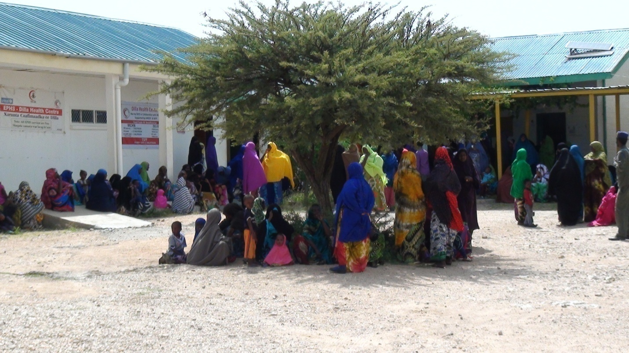
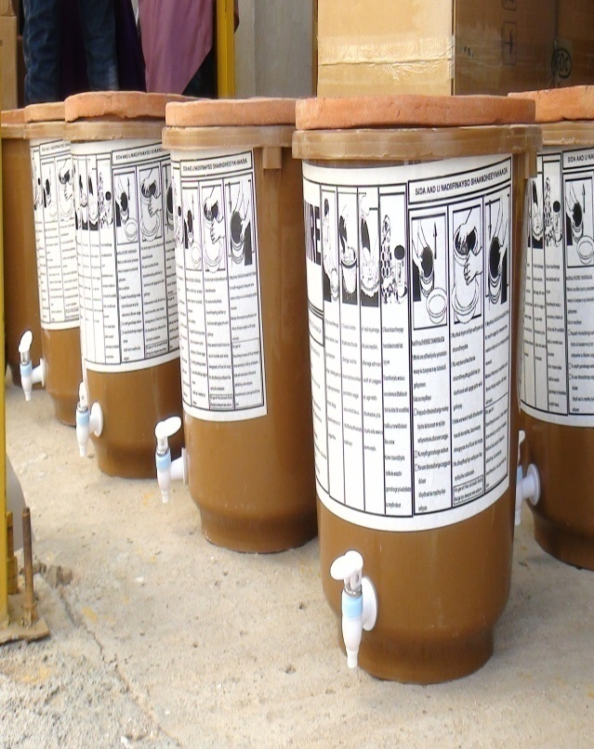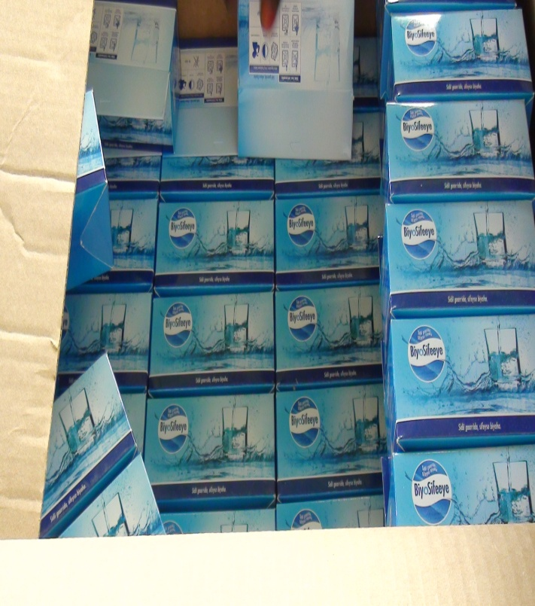
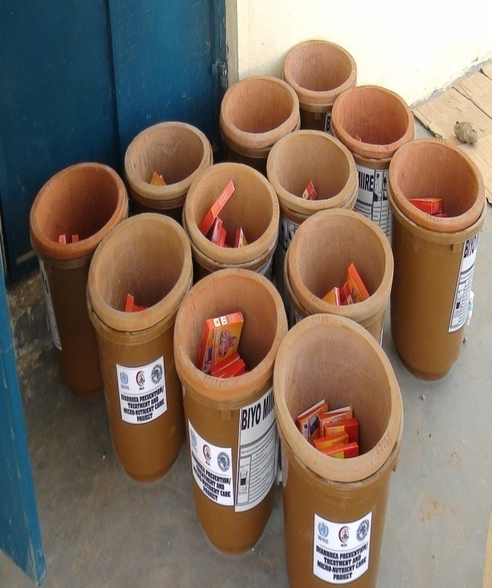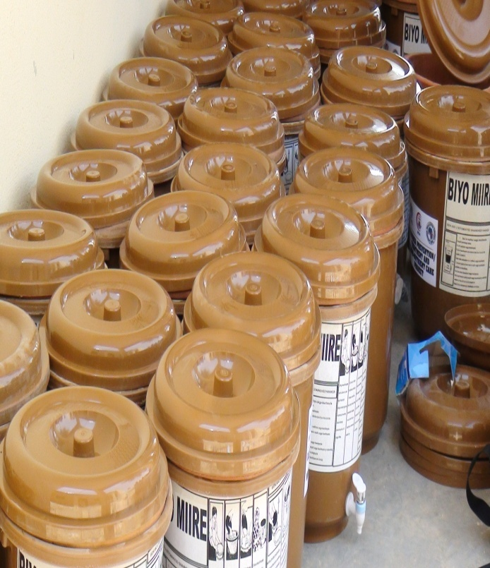
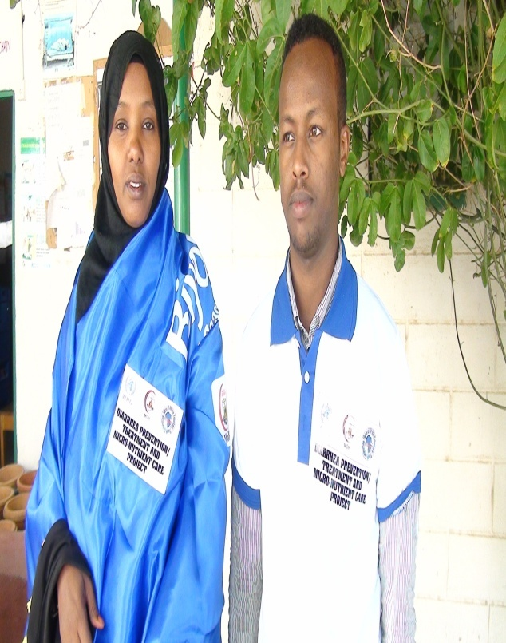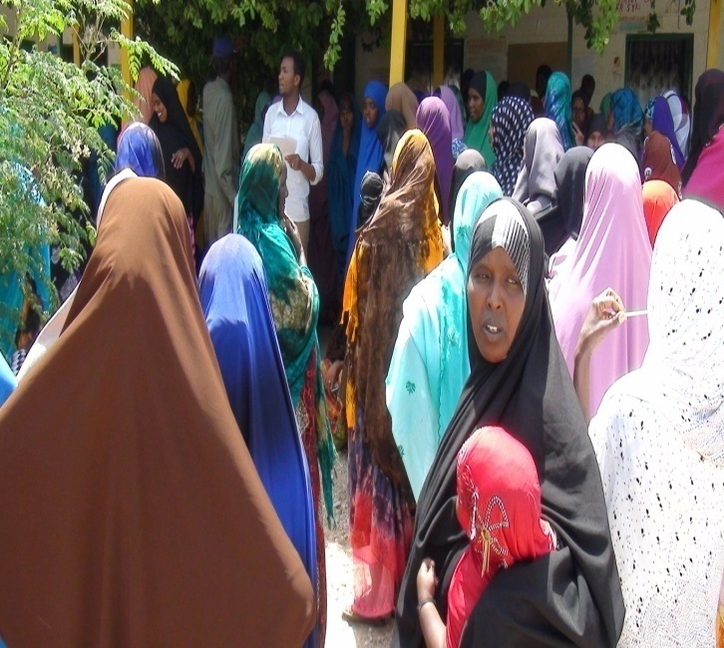

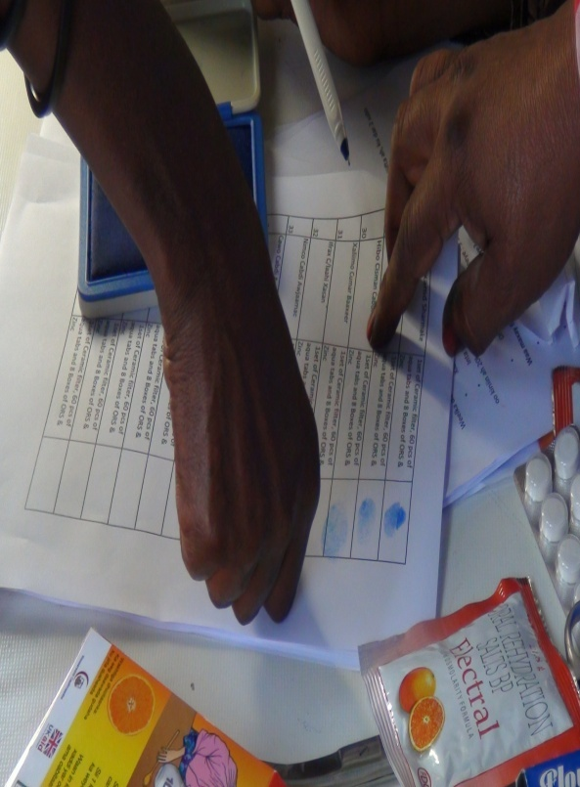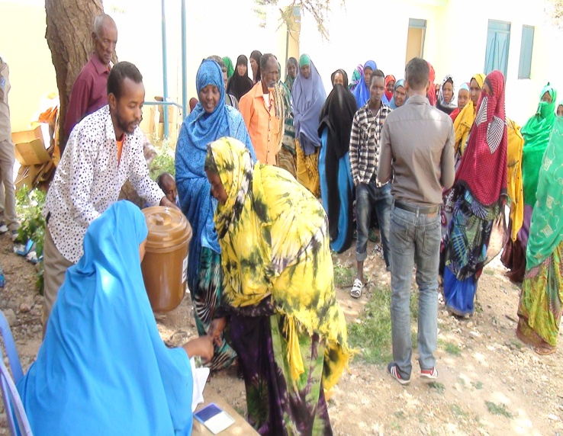
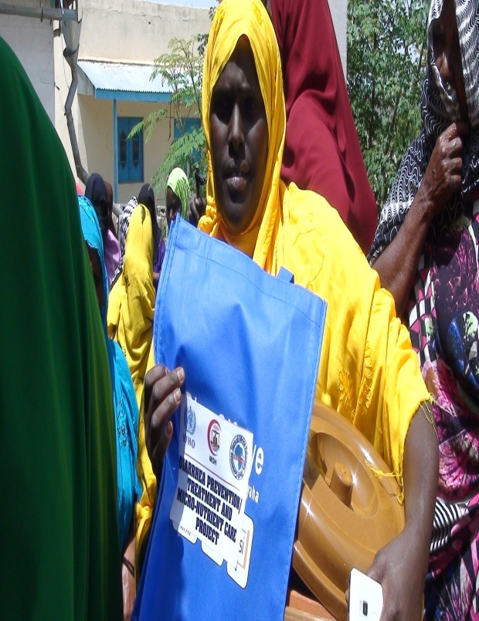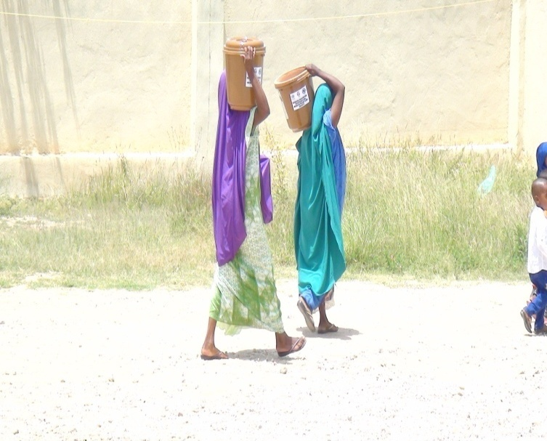

Annex b:List of key governmental officers engaged

- Ibrahim Abdi Hagi,Mayor of Dilla district
- Abdilahi Osman Diriye,The chairman of Kalabaydh Village
- Mohamed Omer Yaabe,Regional health coordinator in Awdal region
- Safiya dhimbiil,Head of Dilla MCH
- Ayanle Nuh Jama,Senior staff of Kalabaydh MCH

